Dana Al Mounayer – s23108503
Lab 3 – Big Data Analytics
Task 1.1
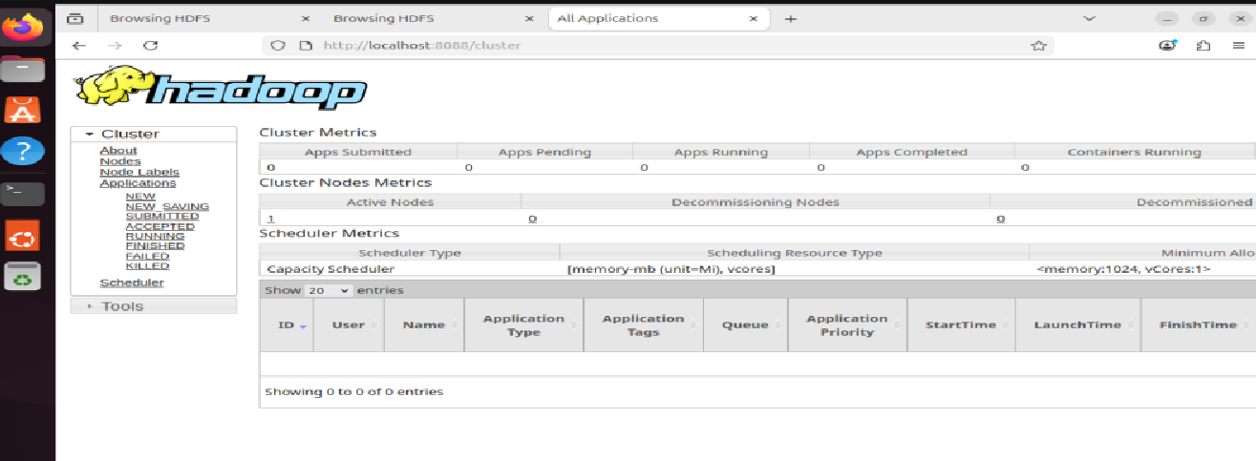
Task 3.2 A
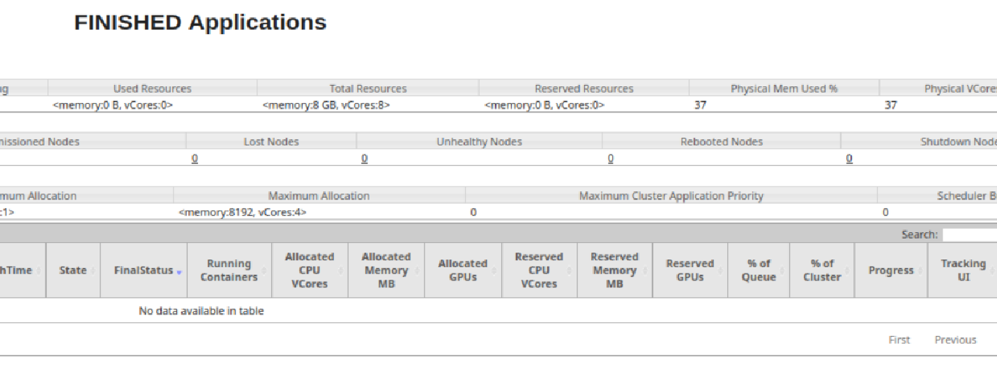
The job ran successfully, shown by the terminal message and the output files _SUCCESS and part-00000 in HDFS. In this setup, short jobs sometimes don’t show up in the YARN Applications table, which is why the table is empty.
Task 3.2 C
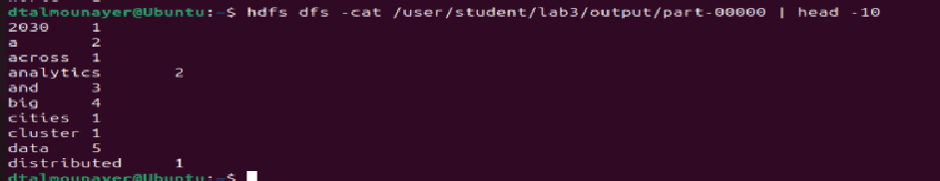
Task 4.1 C
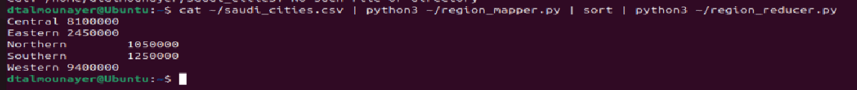
Task 4.2 A) mapper code:
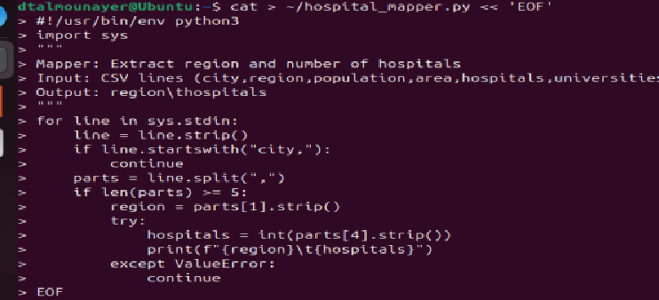
Task 4.2 B) reducer code:
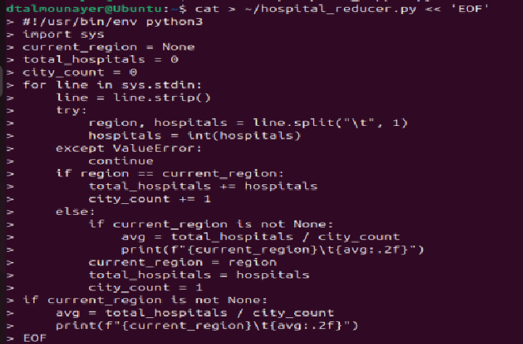

Task 4.2 C) Output:
Task 6.1 A)
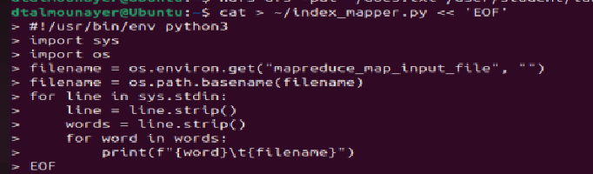
Task 6.1 B)
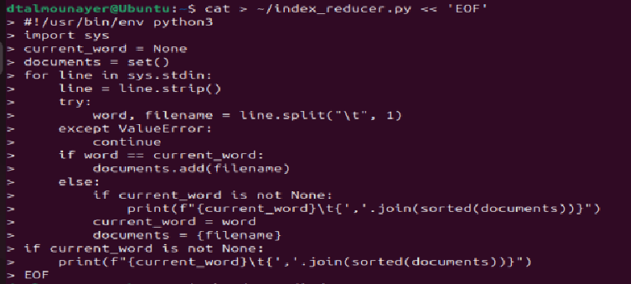
Task 6.1 C)
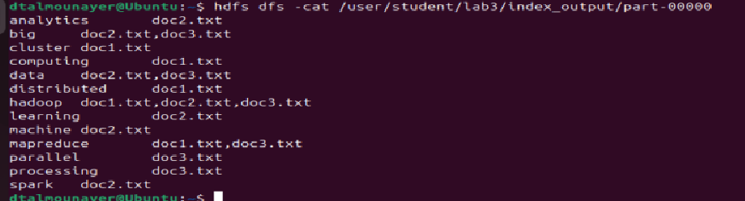
Task 6.2 A)
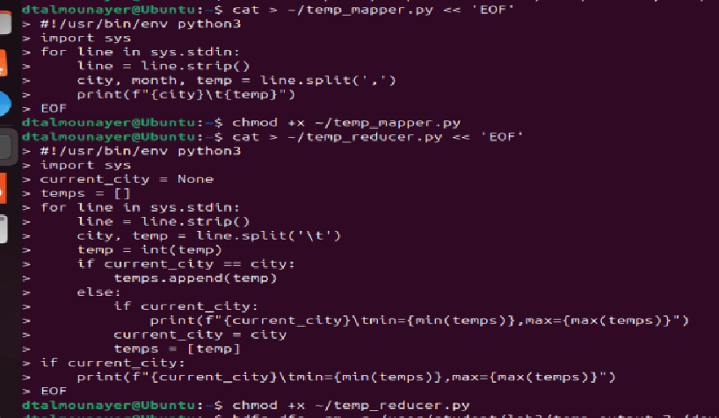
Task 6.2 B)
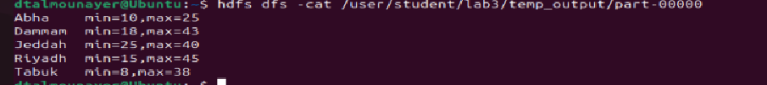
Task 6.3 A)
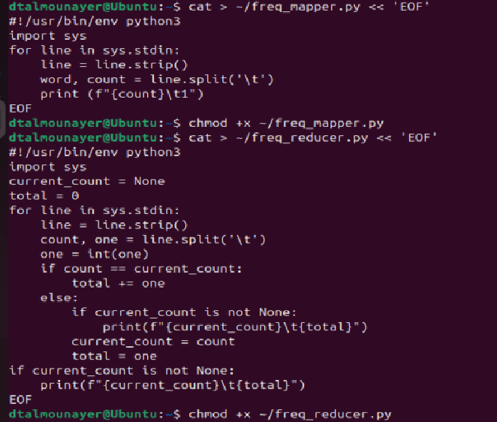
Task 6.3 B)
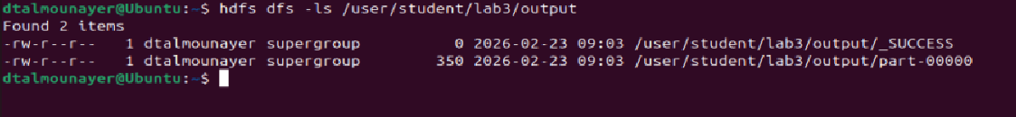
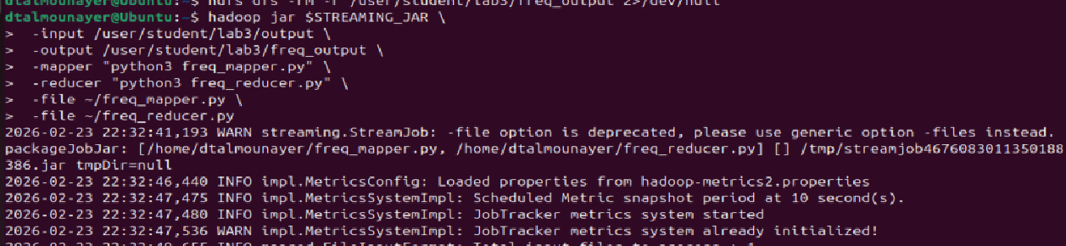
Task 6.3 C)
